“Gunabibi – the story I have been told, the boomerang story echoing around Darwin.”
By James Gaykamangu
Ceremonial leader,
North East Arnhemland
With comment by Dr Bill Day
Darwin
2010

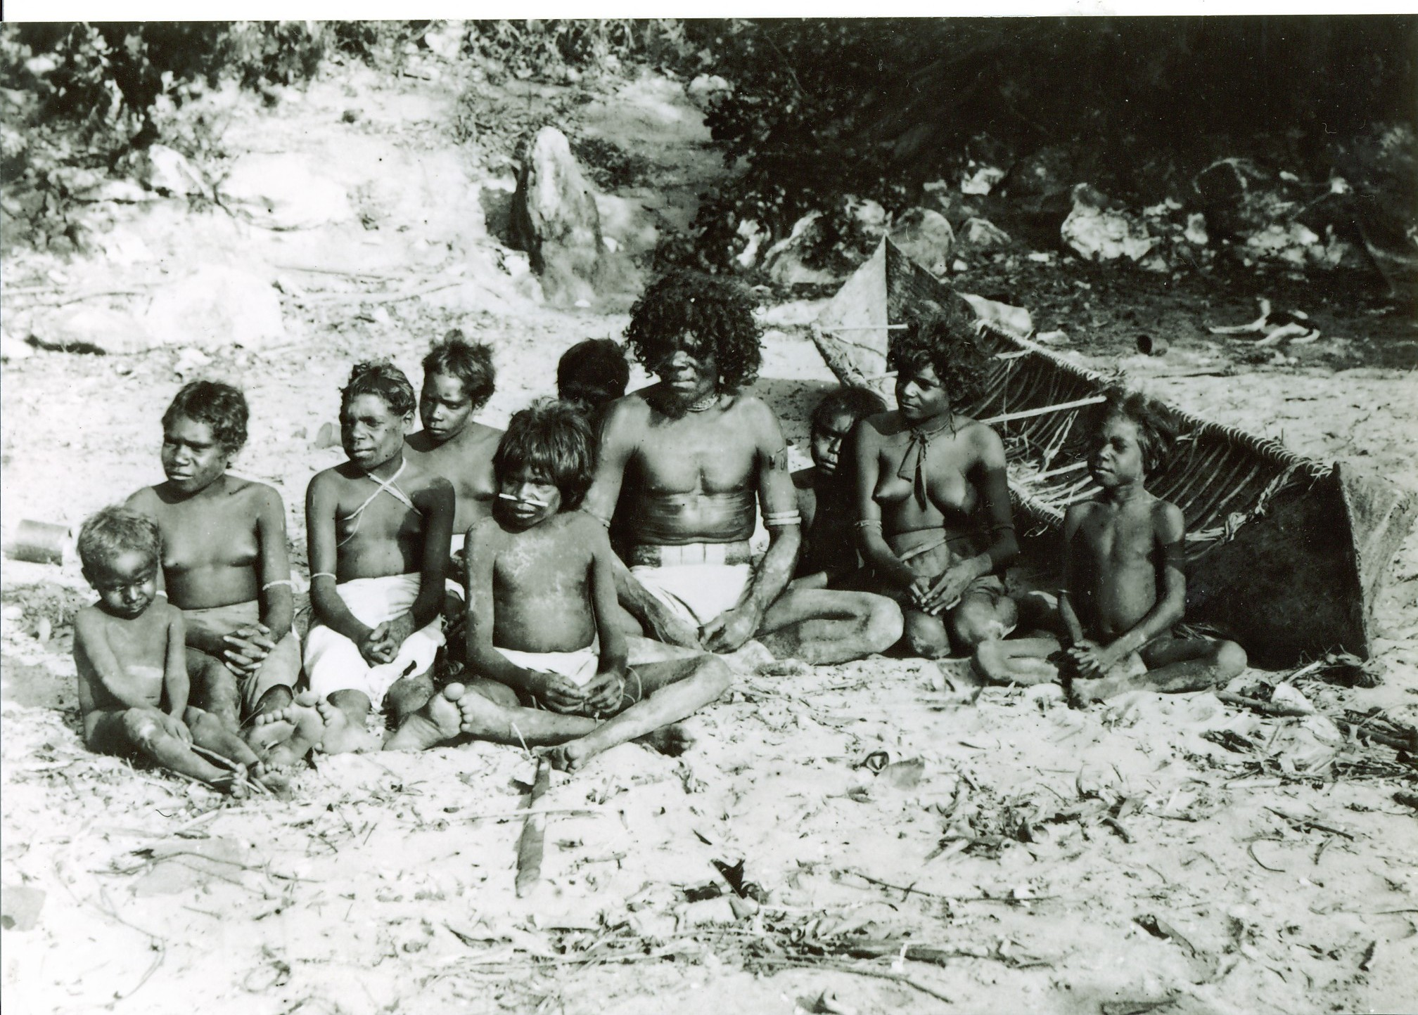
Above: Larrakia people on Lameroo Beach, Port Darwin (Pitt Rivers Museum). Photo from the book
Bunji: a story of the Gwalwa Daraniki Movement, by Bill Day. Aboriginal Studies Press, Canberra, 1994.

“Gunabibi – the story I have been told, the boomerang story echoing around Darwin.”
By James Gaykamangu
Ceremonial leader,
North East Arnhemland
2010
Ceremonial and cultural leaders wrote stories in the book called “Saltwater People: Larrakia Stories from around Darwin”. In this book is clearly stated that Larrakia people carried out private ceremonies in accordance with their Aboriginal law. (Page 2, last paragraph; Page 6 “Larrakia People and Country” on Page 7, the first and second paragraphs). That I confirm that “in 1994 Larrakia Elder Topsy Secretary clearly states and was concerned that many people in Darwin were unaware about the sacred sites, she also states it is not a joke. People might think it’s superstitious but it’s not, it’s real. This was also expressed by another Larrakia man, Bill Risk.
It is also confirmed between 1930 -1932 (Chapter 9, page 159) that Nancy’s mother, Topsy Garramanak, was an important ceremony woman for Larrakia people and for other Aboriginal groups across the Top End. She briefed General McArthur about the ceremonial grounds of location and need to keep people off it.
The last of the person who was inside the Gunabibi ceremony ground in 1953 and in the early 1960s, was Jimmy Miliran who now resides at Ramingining Homeland Garranydjirr.
Topsy Garramanak is sister to Richard Rankin and Daphne Talbot-Alia.
Dolly Gurrinyee is Vivian White’s grandmother. She and Topsy Garramanak were leaders for the Larrakia people before Topsy Secretary and Bobby Secretary, and before Helen Secretary was born. Helen Secretary wasn’t there during the time of the ceremonies.
When the ceremony was on, the young people used to go inside the house and stay there, and they came out when everything was finished. Where Juninga Centre is now, it used to be a billabong and sacred ceremony ground for big serpent. In the afternoons, the serpent used to come out onto the roads and then go back. It used to climb the big trees there too. That area was a sacred ceremony ground which has been bulldozed and houses and Juninga Centre built there. The whole of that jungle area was burial and ceremonial grounds.
Topsy Garramanak was the first ever woman to walk from Darwin to Ramingining, to attend Gunabibi ceremony there representing Larrakia people.
In the time before Darwin was settled by non Aboriginal people, traditional ceremonies occurred on the lands now known as Larrakia lands.
In 1932, these people were Gumatj from Yirrkala. Finity Yunupingu, and Dayngumbu, who was married to (nickname) Nanny Goat, were the ancestors of Nancy Browne, who is part of the Yates family now living in the Humpty Doo, 15 Mile and Acacia areas.
Nancy Browne is Rodney Browne’s mother; Rodney is married to James Gaykamangu’s (author of paper) niece Kathy Marranikuwuy Gaykamangu, now living at Ramingining. Rodney confirms that there was Gunabibi ceremony behind Bagot Community, in the jungle area that was there and also they need to find the shells, where people were collecting and eating. This will mark the spot and the shells might still be there today. This was confirmed on 4th August 2010.
In 1949, Mr Sweeney was a welfare man. In that year, Betty Lee and Sheila White were the Larrakia and Malak Malak elders respectively. Gwen Rankin is a Larrakia woman and in 1949 was a young girl. Joy White was a young girl in 1953, a Malak Malak woman. Sheila White senior and Joy White confirm today there was a ceremony ground behind the now Juninga Centre and Nightcliff Woolworths. Tommy Lyon is a Larrakia elder, and he knew that there was a Gunabibi ceremony, and so did Topsy & Bobby Secretary. This was confirmed on 3rd August 2010.
Sheila and Joy White suggest that Helen Secretary should stop and think first before selling the Larrakia land. They have been pushed to the edge of the salt water, at the edge of the mangroves, and have not been given proper land to live on. A lot of people have been helping them in the past, people from Bathurst Island, Croker Island, Goulburn Island, Milingimbi, Maningrida, and a couple of years later, after 1949, the Groote Eylandt people moved to town and were living in that area, Berrimah first and then Bagot Reserve.
Gurrinyee (or Garrinyi) was a Larrakia lady ‘queen’, like matriarch. She was a cultural leader for womens’ ceremonies during 1953, and she called everyone to come in for that last Gunabibi ceremony. When Joy White and Margaret Woody as young girls used to hear the sound of a boomerang, all the girls go inside the house, because it is a respect of the culture. They were too young to understand that the Gunabibi ceremony was starting.

Vivienne White is the granddaughter for the elderly Dolly Gurrinyee (Garrinyi).

Below: Topsy Garramanak second from right. Parap on right, Harry Adam behind.
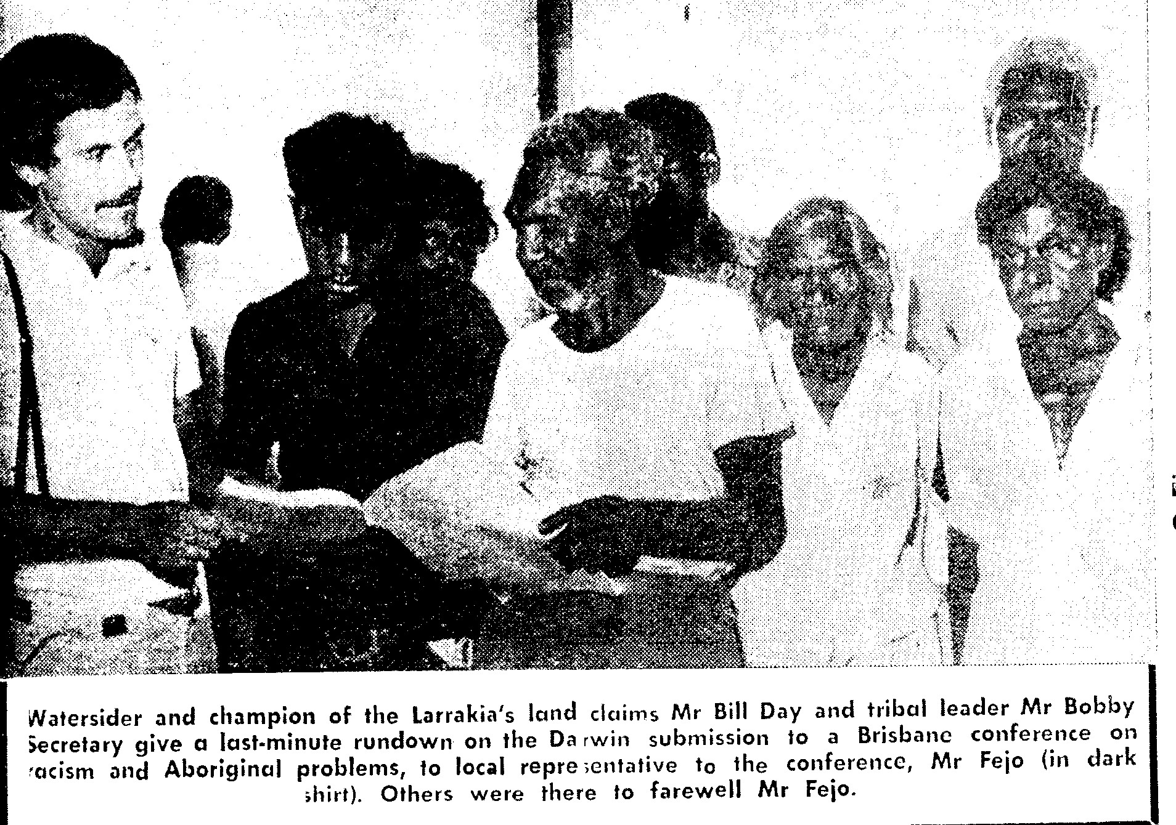
Then in the early 1960s, there was an invitation from a Larrakia traditional leader asking through message stick for people from outside of Larrakia (that is, NE Arnhemland, Central Australia, SE Arnhem, Central Arnhem, Wadeye, Peppimenarti, Daly River, even the WA border) to come into Darwin and have a big Gunabibi ceremony.
This is a ceremony of rite of passage, initiation, discipline & respect for young men and women as they enter adulthood. Respecting each other is a central principle of Aboriginal culture, and Aboriginal people shouldn’t be denying this aspect of their culture, who they are in essence. Aboriginal people should accept ceremonial responsibilities because it is part of us and of the land we live in. It is how we Aboriginal people see it; part of our world view.
The request was for support Larrakia traditional ceremonial leader because he had seen that something was going to happen to Darwin, that it would continue to grow very big, and into a city. His idea at the time was to make a last and final ceremony, and that area should be kept as an historical place of importance, that is a sacred site. This is because people gathered from all over, to support this traditional leader who was fulfilling his commitment to ancient customary law, in the sense of protection of the land. He recognized that as Darwin was growing so rapidly, ceremonies (the coming together of the tribes for important business) would very soon cease to be possible in the Larrakia lands.
The message stick progressed from Darwin to Adelaide River, Pine Creek, Katherine, Mataranka, Elliott, Tennant Creek, Ali Curung, Ti Tree, Alice Springs, other Central Australian communities in the Pitjantjatjara lands, Walbiri lands, Arrernte lands etc., then to Ngukurr, Borroloola, and then to the Daly River region. The message reached the people and they travelled by foot to Darwin; for some, it took a period of three months or maybe more.
The people involved in from North East Arnhem include:
Dayngumbu – elderly Gumatj leader. Married to (nickname) Nanny Goat and now they are Yates family. Nancy Browne (nee Moo) is Gumatj Yunupingu descendent, and her grandmother is Finity Yunupingu (Wulna – Gumatj), closely relates to James Galarrwuy Yunupingu’s family.
Mungurrawuy – is James Galarrwuy Yunupingu’s younger father, and he is Dayngumbu Yunupingu’s brother.
I definitely confirm Nancy Brown (nee Moo) they are closely related to whose father is
Burunggurr – the main Gunabibi boomerang singer
Djirrigulu – boomerang singer
Dawidi – boomerang singer
Roy Rraywala - Djunggaya (caretaker for Gunabibi boomerang singers)
Ray Banakaka – boomerang singer
Rringadjun and Rrangmirr (brothers; both passed away en route, between Darwin and Milingimbi; they tried to help the Larrakia traditional leader)
Walipurru (known as Blue Jean)
Djarrkadam – Barangga woman
Garritjimarra – later went back to Ramingining
Makultja – later, police tracker, Galiwin’ku
Gatji – later, police tracker, Galiwin’ku
Djadjuwuy – public bus driver, later, pearler with Paspaley
Balarra – his song was in the movie Jedda
Milngamuru – later married to a Larrakia woman, and had children
Dayngumbu - later married to a Larrakia woman
Nancy Djindjiniya
Djarrnginy – married to Robert Wukuwuku of Maningrida
Ngurrmili
Bayabaya
The above names are all deceased.
The names of the people from all the other communities are now not known.
Now in that respect, some new generation Larrakia people are saying they want to build a business on that sacred land. They have a right to do that, but other people want that sacred area to be protected, so that it can continue to belong to Aboriginal people as an appropriate ceremonial place.
When the invitation was made by the Larrakia leader in the 1960s, for the Gunabibi ceremony, there were other ceremonies occurring at the same time among the local tribes in the greater Darwin area such as Brinkin, Malak Malak, Larrakia. But Gunabibi was a special invitation across the whole Northern Territory.
We know that this ceremony occurred in the way that is written here because the people listed above have talked about it and confirmed it. Most of them married Larrakia women and their descendents lived here and then moved back to their father’s country in Arnhemland. This story can still be confirmed by descendents today.
This submission does not seek to defend any one party over another, but to tell the story, and give the current issue on potential development some historical context.
We Aboriginal people need to stand together as a nation and help each other in this kind of circumstance, to protect the old ceremonial areas so that they remain part of our culture and remain as historical sacred sites now and for future generations. We are living in a modern society, and we know that there is always pressure for development of land, even by Aboriginal people who may have a right to do so, but she needs to talk to the Browne family, and Mills family, and White family, and Thompson family, and Fejo family, and Rankin family about that land. They all owners of that land too, and we outside people also have an interest through the ceremonial issues. We need to talk with someone who is a Larrakia leader to resolve this together. We could see if there could be a memorial erected there to show the historical and ceremonial importance of the site.

James Gaykamangu
Bagot Community
Ceremonial leader, North East Arnhem
September 2010

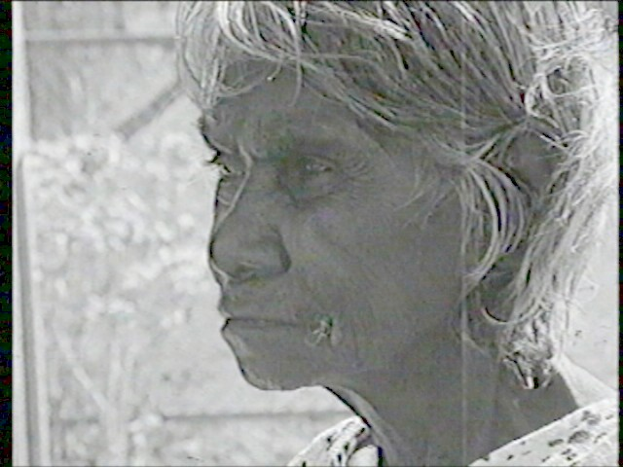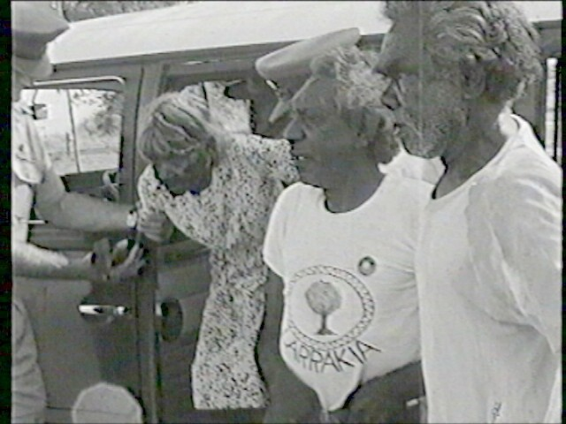
Above left: Dolly Gurinyee (Larrakia Elder) in 1972.
Above Right: Dolly, Bobby Secretary, Captain Bishop (Larrakia elders) visit Larrakeyah Army Barracks to visit the old Gundal ceremony ground at Emery Point.

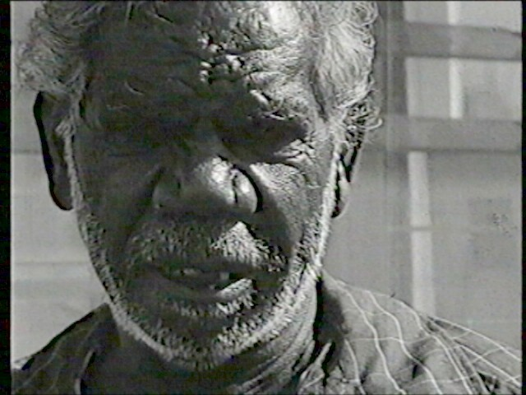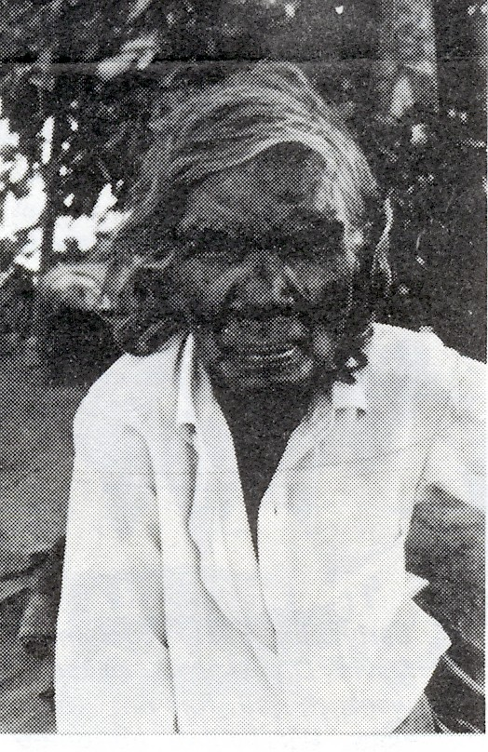
above left: Norman Barral Harris (Larrakia elder) in 1972. Right: Topsy Garramanak.

THE NEED TO RECCORD SIGNIFICANT SITES ON THE KULALUK LEASE –
THE GUNABIBI CEREMONY GROUND: OF SACRED AND HISTORICAL IMPORTANCE.
In 1982 the director or the Aboriginal Sacred Sites Authority (ASSA), David Ritchie, wrote to the Gwalwa Daraniki Association, notifying the association of significant Aboriginal sites on the Kulaluk special purpose lease. In his letter, Ritchie noted that an area behind the Bagot Community lease is an important Gunabibi ceremony site according to an Arnhem Land leader and politician, since deceased. Despite Ritchie’s concern, the site has never been registered as a sacred site and apparently little was recorded about the circumstances that led to such an important ceremony being held in the Darwin area.
In 2010 the Kulaluk leaseholders applied to the Northern Territory Department of Lands and Planning, now headed by the same David Ritchie, seeking to rezone several areas on the lease, including the area recorded as the Gunabibi ceremony site. As a result, on July 22nd, 2010, a hearing was held in the Brolga Room of the Novatel Hotel before Peter McQueen, Chairman of the Development Consent Authority (DCA). Coincidentally, Mr McQueen represented the Gwalwa Daraniki Association in eviction proceedings against Bill Day in 1983-5. When McQueen was asked if his previous involvement suggested a conflict of interest, he claimed he could not recall the eviction case and asked for evidence (see attached letters).
At the hearing, Mr James Gaykamangu, a resident and past president of the Bagot Community, related how the Gunabibi ceremony came to be held on the site in what was then part of the old Bagot Reserve. Mr Gaykamangu’s evidence revealed a little-known perspective to the site as part of the untold Aboriginal history of Darwin, and as such a site of great historical importance. This perspective further exposed the research of the developers and the supposed cultural authority of the leaseholders who claimed that there were no cultural impediments to rezoning the Kulaluk land for residential and light industry.
Greg Constantine, the CEO of the Larrakia Development Corporation, who presented a late submission in favour of the rezoning suggested that Mr Gaykamangu’s evidence was irrelevant because he is a Yolngu man, and not Larrakia or a member of the Gwalwa Daraniki Association. However, Mr Gaykamangu has considerable cultural authority in his role of advocate for Aboriginal customary law. In addition, his remarkable eyewitness account included lists of participants and other details.
In 1965, the Bagot Aboriginal Reserve was reduced from 700 acres to 57 acres to create the subdivision of Ludmilla that was eventually to surround the reserve on three sides. Not surprisingly at this time the Larrakia people grew so concerned at the spread of the town over their traditional lands that Larrakia elders decided to send message sticks across the Northern Territory to call Law men into Darwin in support of the Larrakia. History records a similar concern by the Larrakia when Kahlin Compound was to close and plans were made to move its Aboriginal residents further out of town. According to the late Bobby Secretary, his father then chose the site of Bagot Reserve, from Ludmilla Creek to Totem Road. Inevitably, ceremonies were held in the surrounding bushland and the late Larrakia leader, Mr Victor Williams, recorded that hundreds of burials were made throughout the reserve in the days when Aboriginal people were not usually buried in registered cemeteries.
According to James Gaykamangu, when his father received the message stick he felt obliged to support the Larrakia and organised for 19 men to walk to Darwin to conduct such highly significant ceremony, along with Law men from various other communities. Tragically, the elder was to lose two of his sons during the two months trek across Arnhem Land into Darwin. Then, when everyone was assembled, the Gunabibi ceremony was held in bushland behind Bagot Reserve, as shown in maps filed in the Aboriginal Areas Protection Authority (AAPA), as ASSA is now known. Unfortunately the ceremony site and many other sites on the Kulaluk lease were never registered.
During the hearing on July 22nd, the proponents and the leaseholders discounted Mr Gaykamangu’s evidence by suggesting that no important ceremony was held at the site, the area was a rubbish dump and that the events occurred a long time ago. Helen Secretary was particularly critical of Mr Gaykamangu’s story, claiming that the area was no more than a ‘sit down’ site and of as such it was of no importance to her people.
On the contrary, the events leading up to the Gunabibi ceremony appear to suggest an untold chapter of the history of the Larrakia people that needs to be properly documented. It is fortunate that witnesses like James Gaykamangu are still alive, as most of those who took part in the historical events have passed away. Indeed, Mr Gaykamangu shares a sense of urgency to record the cooperation between Larrakia people and other language groups concerned by the loss of lands in Darwin. As well, the epic events may shed light on a paragraph of the famous bark petition for land rights that expresses a fear that North East Arnhem Land clans will suffer ‘the same fate as the Larrakeah’.
Considering all of the above, it is imperative that the group known as the Larrakia Law Ground Custodians immediately begin the process of recording and registering the site and other associated sites on the Kulaluk lease as significant Larrakia historical, cultural and perhaps even archaeological sites before these and other sites are destroyed by the development plans of the Gwalwa Daraniki Association. Mr Gaykamangu and other older Yolngu people can confirm the importance of at least two sites and Tiwi elders may have information on other sites. The CEO of AAPA says that the Authority already has a file on the Gunabibi site plus other site recordings that may be useful.
The involvement of the Larrakia Development Corporation in plans to develop the Kulaluk Lease suggests that its Chairman is unaware of the presence of significant sites and as already stated the President of the Gwalwa Daraniki Association denies them.
Dr William B Day
Consulting Anthropologist
Darwin
24th July 2010

PO Box 425
Maylands
WA 6931

17 August 2010

Chief Executive Officer
Aboriginal Areas Protection Authority
GPO Box 1890
Darwin
NT 0801

Dear Ben

RE: KULALUK LEASE SITES
Thank you for attending the Darwin Consent Authority hearing into the Kulaluk rezoning applications on July 22nd last. I enclose a summary of the discussion about the Gunabibi site mentioned by David Ritchie in his letter to the Gwalwa Daraniki Association in 1982, written in his role as head of Aboriginal Sacred Sites Authority (ASSA). In more recent times I was surprise to discover further details about the origins of this site and that it retains such significance amongst living people like James Gaykamangu of Bagot Community, elders in Arnhem Land and the Larrakia people. I urge AAPA to record James’ story urgently because he is not in the best of health and was uniquely involved in events never recorded, to my knowledge. Don White of Bagot Community is another man who knows more about the site.

You said that AAPA has a file on the Gunabibi site, so you may already have enough information to register the site. The Hollingsworth Consultants’ report, ‘Kulaluk Lease Land Development Study’ (1985) (NAC Q 711.552 Hol, NT Library) includes a map that shows the Gunabibi site and another large site behind the old Retta Dixon Homes. The Hollingsworth map seem to coincide with the map in Henderson’s ‘Land Use Field Study of the Kulaluk Area’ (1983), so I suspect the researchers both used information from AAPA, or the Aboriginal Sacred Sites Authority as it was then. I am also recall when David Cooper was working for ASSA in the 1980s he had maps with sites marked along Ludmilla Creek and another site in the bushland beside Fitzer Drive. I presume these sites were not registered because the land was Aboriginal land leased to the Gwalwa Daraniki Association and was thought to be in safe hands.

As the rezoning applications have shown, the land is not secure. In talks at Larrakia nation on July 30th, I urged the group of men known as the ‘Larrakia Law Grounds Custodians’ to register the Gunabibi site with AAPA as soon as possible, as the men are doing for the old initiation ground at Emery Point. I stressed that the matter is urgent; however, owing to the unfortunate upheaval at Larrakia Nation, the men may not have followed the matter up.

I do know that James Gaykamangu has begun his own research and interviews. He is very happy to share the information with anyone who can help save the areas. James was very offended when I told him about the remarks by Greg Constantine and Helen Secretary who gave their oral submissions after James had left the hearings room. You will remember that Greg and Helen discounted James’ version of events and reasserted their opinion that there were no cultural impediments to developing the bush land between Harney Street and Dick Ward Drive. I still do not understand what Greg Constantine and the Larrakia Development Corporation have to do with the Kulaluk lease. I think Greg described themselves as ‘partners’ and Helen Secretary as ‘a senior traditional owner’.

Rather than wait for someone to start the ball rolling and register the site, my request is that AAPA begin the necessary documentation to register the Gunabibi ceremony site and the Tiwi burial site, as well as any others that James Gaykamangu, Don White and anyone else may know about.

From my point of view, I would like to have the whole of the Kulaluk lease registered as a site of historical importance. This would include Ludmilla Creek, Fred Fogarty’s old camp, my old camp, the concrete army observation post, the old Chinese wells, the old rice fields and dyke, many heritage trees, the burial grounds, tracks used for access, all the mangroves, fishing and shell fish gathering sites, middens, jungle fowl nests, old army rifle range, Mirage crash site, Fred Fogarty’s tree plantings, possible archaeological sites (including pre-1970 rubbish dumps), bird breeding and roosting area, the salt pan (roosting site for migratory birds), and more (Note: the salt pan was excavated for aquaculture ponds in 1997 – with the failure of the aquaculture ventures, the permit states the environment must be restored).

Of course the whole Kulaluk lease area from Totem Road to Ludmilla Creek also has historical and cultural significance in having been the site of the old Bagot Reserve from 1938 – 1965. The final report of the Aboriginal Land Rights Commission in 1974 documents in nine pages the story of how the reserve was revoked in 1965. No one has really documented the activities that took place on the land in that period. According to the late Victor Williams there were at least 200 burials. Later, from 1971 to 1979 the land was the centre of the national land rights struggle, as recorded in the newsletter Bunji from 1971 -1985.

I am sure that ASSA and AAPA were working towards the same aim of preserving the Kulaluk land by their support of the research of David Cooper and Krimhilde Henderson between 1983-5. The results of that research, including Henderson’s two reports (‘Land Use Field Study of the Kulaluk Area’ and ‘History of the Kulaluk Lease’) would have been kept by AAPA to be a valuable resource. Also, Sam Wells’s comprehensive history, ‘Town camp or homeland? A history of the Kulaluk Aboriginal community’ (1995) was sponsored by the Australian Heritage Commission with the intention of placing the Kulaluk land on the national heritage register. As you may have noticed, rather than having these three above mentioned and well-documented reports mouldering in the archives, I have made multiple copies at my own expense and distributed them to interested people.

I urge AAPA or the Heritage Commission to register the Kulaluk lease in its entirety with some urgency, but not, dare I say, with the present leaseholders as custodians! In my role as an anthropologist I will also work towards the same end, before valuable information is lost.

Yours sincerely,

Bill Day
Consulting Anthropologist

By Samantha Wells, 2001. Published by Larrakia Nation Aboriginal Corporation.

